<https://www.youtube.com/watch?v=3HaN8AFQnoA&feature=youtu.be>

Outer/show mat = white Under/accent mat = black

1. Cut the accent (under mat) mat a little smaller than the outer mat [1” smaller on 2 sides; therefore will be 1/2” smaller on each side)
2. Measure, mark and cut the window of the over (show) mat
3. Use double-face tape on the inside edges of the over mat and an “X” on the window that fell out (see below). You will need the stability through the center of the over-mat as you cut the under-mat.

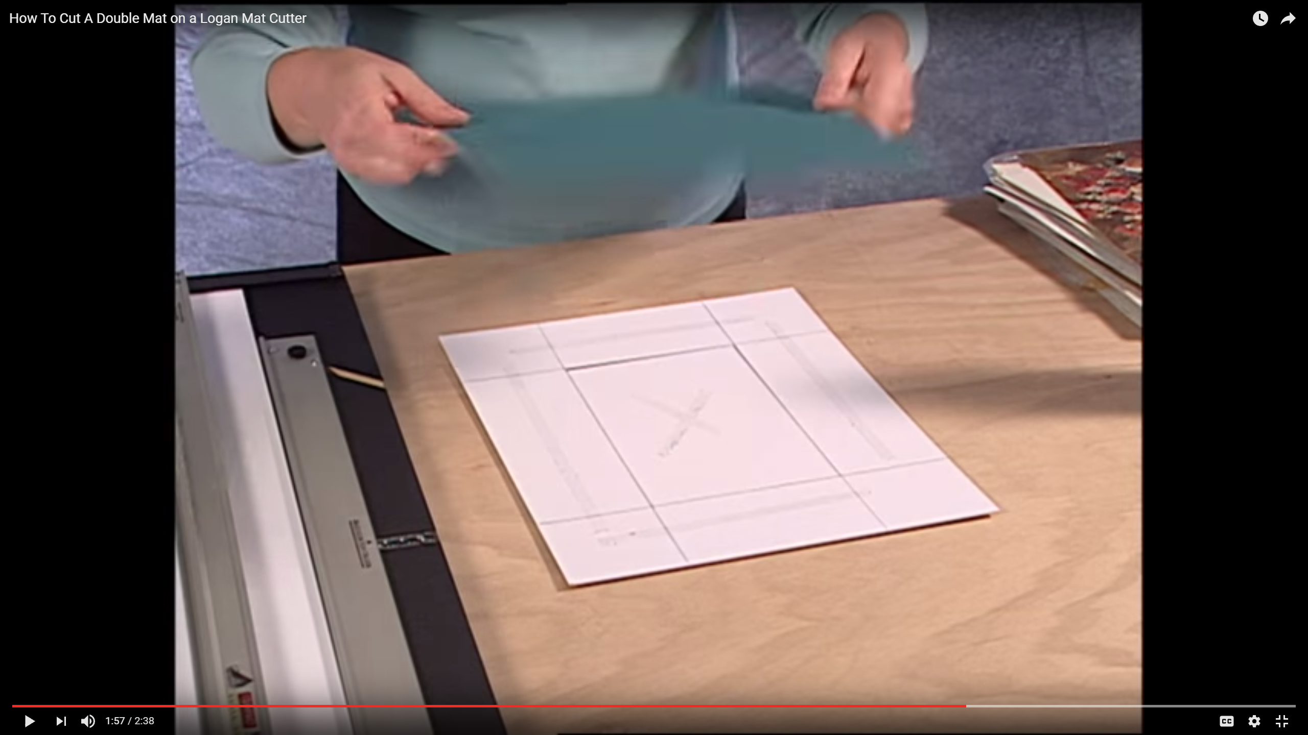

1. Place the accent mat face down on the tape of the outer mat **BEFORE** you cut the window of the accent mat
2. Adjust mat cutter so the border is 1/4” larger than the original border (the window will be 1/4” smaller on each edge)
3. 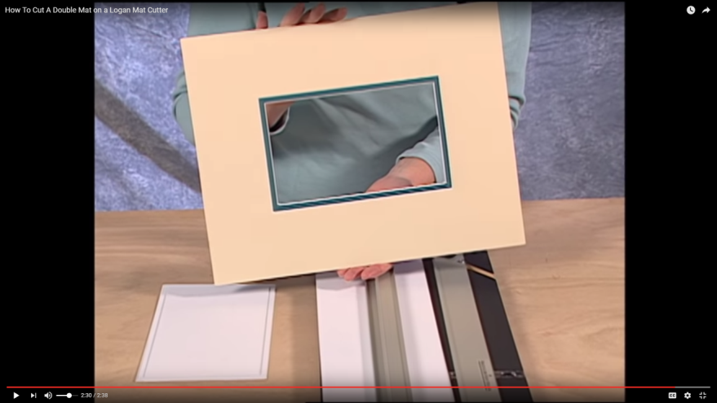Mark and cut 4 sides; windows, which are stuck together will fall out